Events & Calendar Management

Introduction
The Events & Calendar Management module allows administrators to create and manage events efficiently. Events can be categorized as private or public, helping in organizing internal activities and notifying members about upcoming events.

How to Access Calendar
- Login to the system using Admin credentials.
- From the left navigation pane, click Calendar.
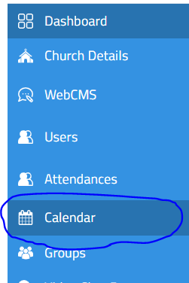

How to Create an Event

Step-by-Step Procedure
- On the Calendar page, click the Create Event button located at the top-right corner.
- Choose the type of event from the dropdown:
  - Private Event
  - Public Event
- The event can be a private or a public event
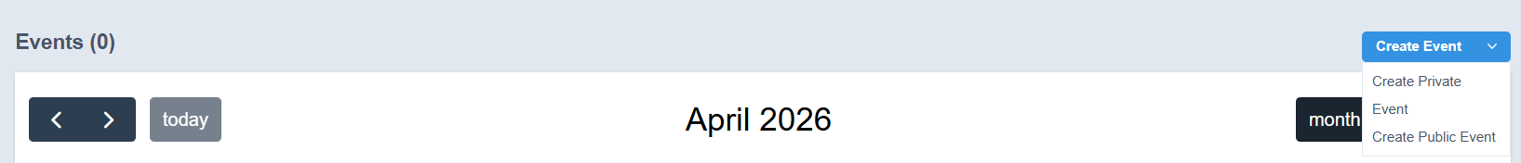

Creating a Private Event
- Click Create Private Event from the dropdown menu.
- A new event form will open.
- Enter the required details:
  - Title
  - Description
  - Repeats
  - Location
  - Event Category
  - Organized By
  - Start Date & Time
  - End Date & Time
- Click Submit.

Outcome
- The private event will be created successfully.
- It will be displayed in the calendar but limited to internal visibility.
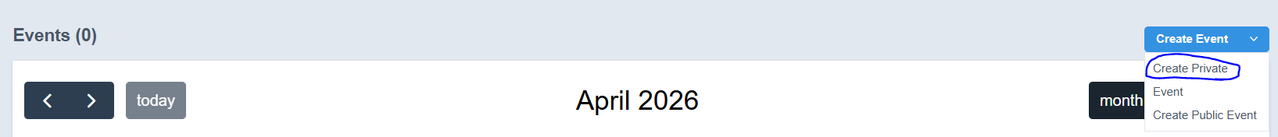

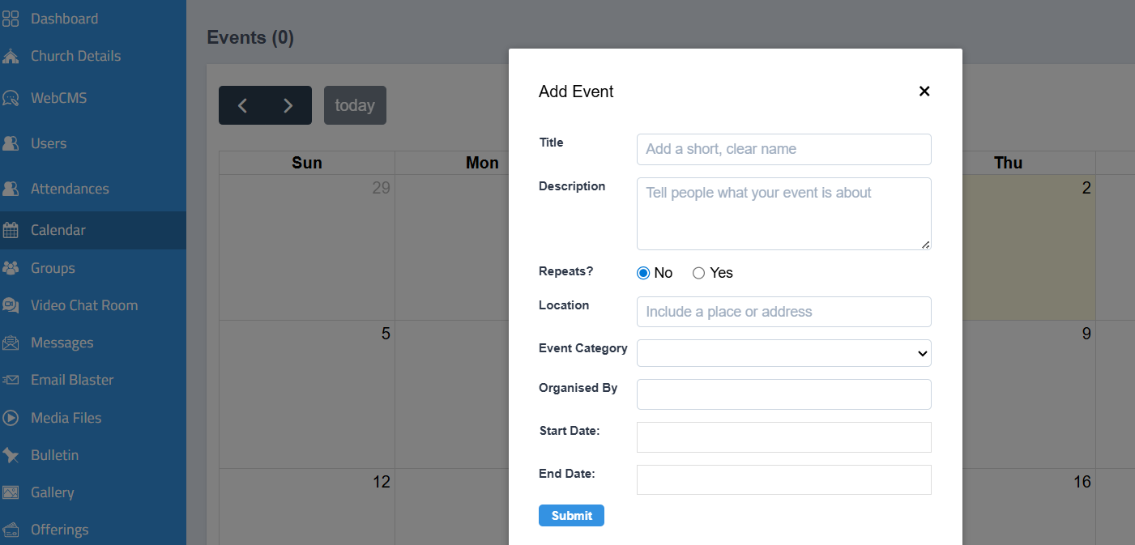
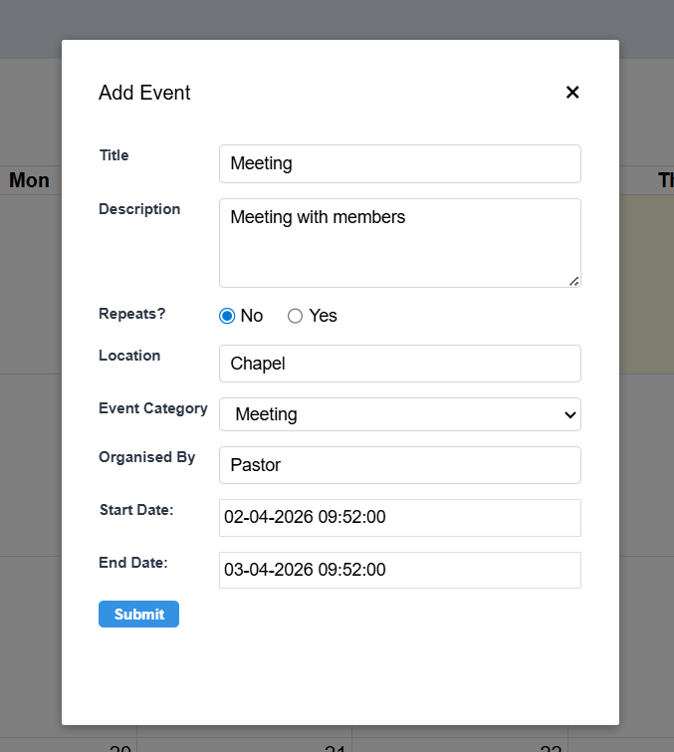
A new event will be created in the calendar and will be listed.
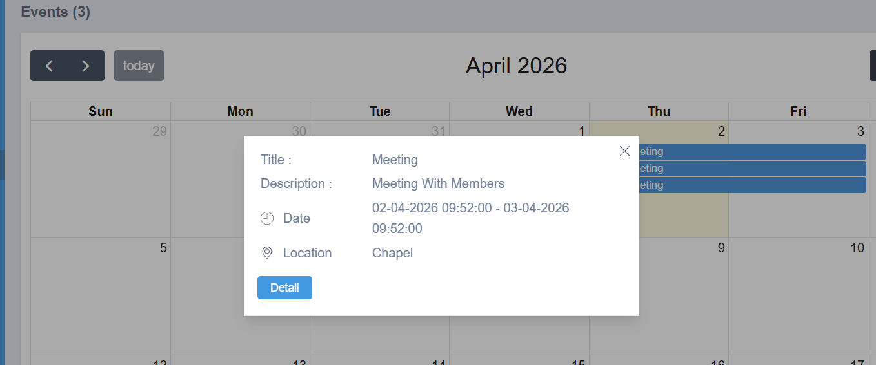

Creating a Public Event
- Click Create Public Event from the dropdown menu.
- Fill in all the required event details (same as private event).
- Click Submit.

Outcome
- The public event will be created successfully.
- The event will be visible in the calendar.
- Notifications will be sent to members through the member application.
Notes
- Ensure all event details are entered accurately before submission.
- Public events will be visible to members, while private events are restricted to internal users.
- The members can view their calendar of events in the monthly calendar.
